**BACKGROUND:**

* This research project is to test whether the gender of a virtual conversational agent on a fintech platform will have any effect on user experience.
* The gender of a virtual conversational agent can be expressed in 2 ways: the appearance of the avatar and the communication style of the chat.
* This research project is interested in testing both aspects.
* To test both aspects, the project will be split into 2 studies: Study 1 and Study 2. Study 1 and Study 2 are done with separate groups of participants.
* Study 1 and Study 2 follows the same flow, but there will be different number of conditions and different scripts to flow. Detailed descriptions of Study 1 and Study 2 provided below.
* There will also be an Online Pilot Study

**STUDY 1:**

***Overview:***

Study 1 is only concerned with testing the effects of changing the appearance of the virtual agent. The script is fixed and will be Neutral.

***Flow of experiment****: The whole experiment consists of participants chatting with the virtual agent. Over the course of the conversation, participants will engage in three tasks with the virtual agent (choosing bank account, choosing home loan plan and choosing insurance plan).**After the completion of each task, participants will be click “Next” to a page to answer some questions (same as Yihan’s project). Upon completion of the short survey, participants will click “Next” to resume the conversation. Please refer to the Script document for the questions*

Breakdown of steps:

1. Participants will first view a short introduction page about the virtual agent (new update from Cui Min).
2. Participants will then start chat with the virtual agent. (Steps 2, 3 & 4 are repeated, only the task within each step changes)
   1. The chat will lead to the virtual agent helping the participant to choose a bank account.
   2. After the bank account recommendation is given, participants will click “Next” to do a survey.
   3. Upon completion of the survey, participants will click “Next” to resume with chat.
3. Participants will then resume chat with the virtual agent.
   1. The chat will lead to the virtual agent helping the participant to choose a home loan plan.
   2. After the home loan plan recommendation is given, participants will click “Next” to do a survey.
   3. Upon completion of the survey, participants will click “Next” to resume with chat.
4. Participants will then resume chat with the virtual agent.
   1. The chat will lead to the virtual agent helping the participant to choose an insurance plan.
   2. After the insurance plan recommendation is given, participants will click “Next” to do a survey.
5. End of experiment.

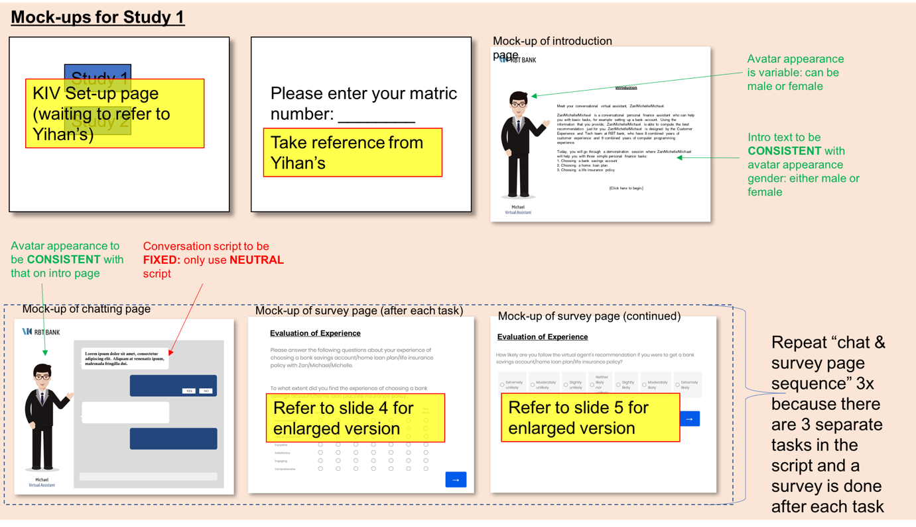

Figure: Diagram to represent flow of Study 1 (Refer to PowerPoint Document for better view: Experimental Flow Diagrams 12.06.18)

**STUDY 2:**

***Overview:***

Study 2 is the same as Study 1, except now we will vary the communication style.

***Flow of experiment****: The flow of experiment is the same as study 1. The only difference is that the script will be different and varied between Neutral, Male & Female (refer to script document).*

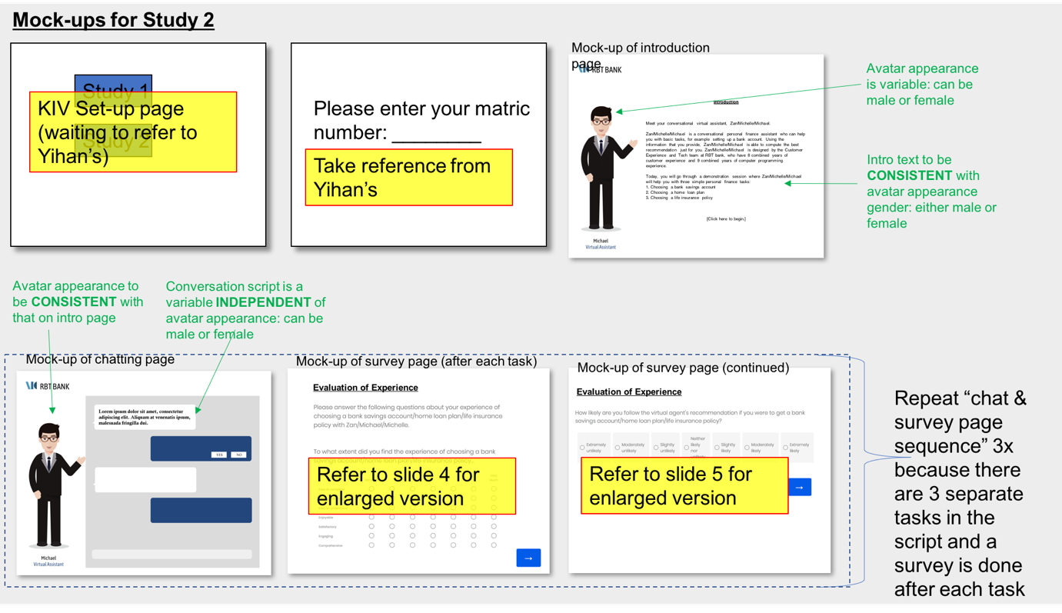

Figure: Diagram to represent flow of study 2 (Refer to PowerPoint Document for better view: Experimental Flow Diagrams 12.06.18)

**ONLINE PILOT STUDY:**

***Objective:***

The objective of the pilot study is to test that my manipulations work as desired (e.g. experiment participants will perceive the male script to sound like a male, without the influence of the appearance of the avatar)

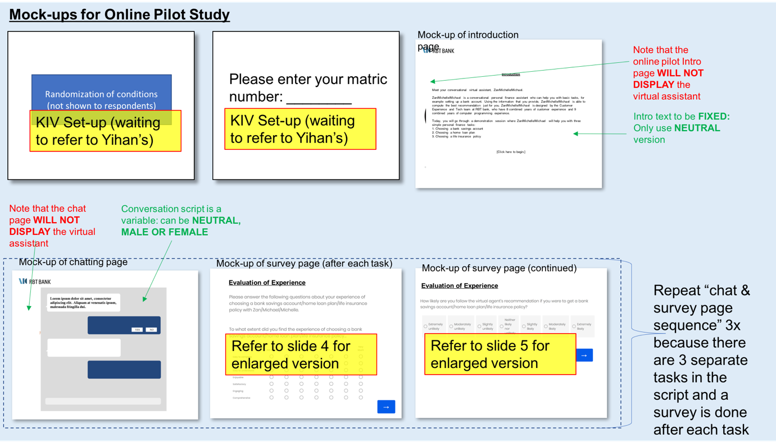

Figure: Diagram to represent flow of online pilot study (Refer to PowerPoint Document for better view: Experimental Flow Diagrams 12.06.18)